Andrey Yerin, August 2023
andrey.erin@acdlabs.com
Enhanced Stereochemical Representation and its Relation to the Nomenclature
Reference:
IUPAC project 2019-017-2-800: Enhanced recognition and encoding of stereoconfiguration by InChI tools
While the project mostly deals with InChI tasks, the part of it deals with ‘enhanced stereochemical representation’ (ESR) that is related to general structure representation principles and has nomenclature aspects.
Summary: The document describes the principles of ESR already used in electronic structure representation for concise designation of mixtures of stereoisomers for acknowledgement by IUPAC for graphical structure representation standards. The corresponding principles of concise and unambiguous designation of stereoisomer mixtures in chemical names are discussed. These extensions in representation and nomenclature guidelines are necessary for designation of chemicals that are often mixtures of stereoisomers.
Enhanced stereochemical representation
ESR was introduced by MDL Information Systems as a part of electronic structure representation in MOL file format V3000. This extension of MOL file format addressed the need f concise designation of substances that are a mixture of stereoisomers or have partially known configuration that are very common in industrial chemistry. The details of ESR can be found at
https://discover.3ds.com/biovia-enhanced-chemical-representation
ESR uses three variants of marks for stereocenters:
- ‘abs’ (absolute) – having a configuration as defined in the structure, label ‘abs’ is normally omitted;
- ‘&’ (‘and’, ‘racemic’) – molecules with a designated and an opposite configuration of stereocenter;
- ‘or’ (‘relative) – molecules with a designated or an opposite configuration of stereocenter
Example 1: a mixture of two stereoisomers prepared from racemic butan-2-ol and (2R)-2-hydroxypropanoic acid
Traditional | 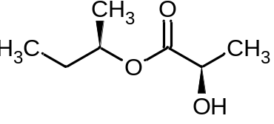 | and | 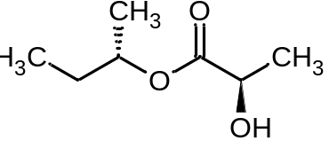
ESR | 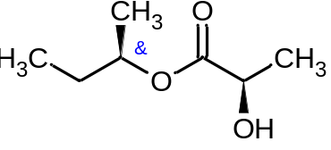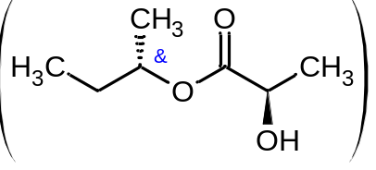
For ESR two representations are treated as equivalent.
Example 2: a mixture of ester of either (2R) or (2S)-butan-2-ol and (2R)-2-hydroxypropanoic acid
Traditional |  | or
ESR | 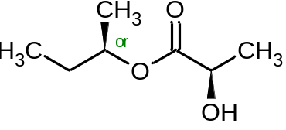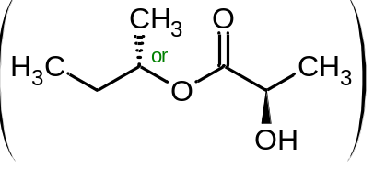
For ESR two representations are treated as equivalent.
Example 3: A mixture of two enantiomers – dependent stereocenters.
Traditional | 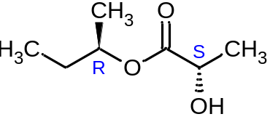 | and | 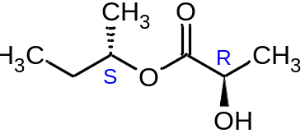
Current recommendations  (ESR variant) | 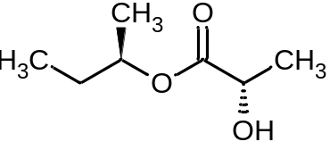 |  |  | and enantiomer
ESR | 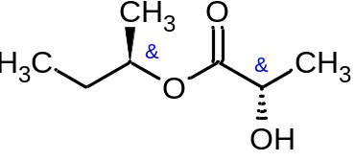
ESR marks are the same – either with or without index.
Example 4: A mixture of four stereoisomers – independent stereocenters.
Traditional | 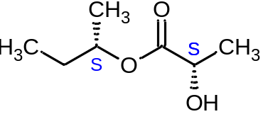 | and | 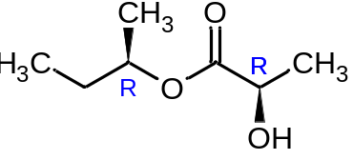
ESR | 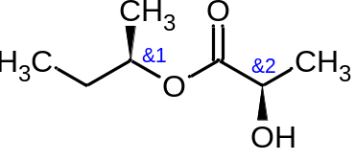
Note that for independent centers indexes for marks are different.
Other equivalent representations are possible for ESR.
The presence of exactly one but unknown stereoisomer from several possible can be defined in the same way using ‘or’ marks.
The convenience of ESR can be demonstrated for designation of cypermethrin group pesticides that is
cyano(3-phenoxyphenyl)methyl 3-(2,2-dichloroethen-1-yl)-2,2-dimethylcyclopropane-1-carboxylate
having three stereogenic centers and eight possible stereoisomers:
Cypermethrin | A mixture of all possible  eight stereoisomers | 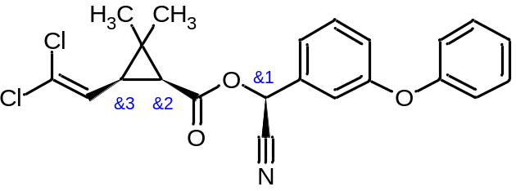
ζ-Cypermethrin | Four stereoisomers:  S,1R,3S;  S,1R,3R;  S,1S,3R;  S,1S,3S | 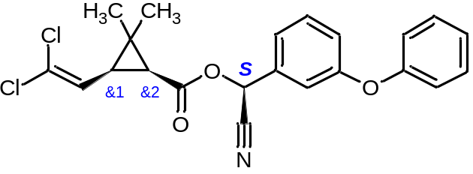
α-Cypermethrin | Two stereoisomers:  R,1S,3S and S,1R,3R | 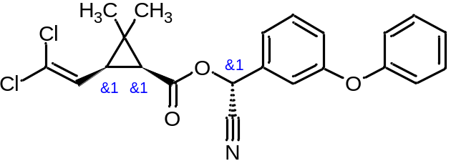
θ-Cypermethrin | Two stereoisomers:  R,1S,3R and S,1R,3S | 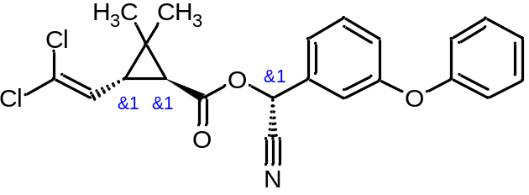

We can see that ESR allows designation of mixtures of stereoisomers or isomers with partially known configurations in simple and compact way. While ESR currently has limited use in printed sources, this representation is well accepted and used in electronic representation and especially in industrial chemistry. It would be useful if IUPAC considered this representation convention for inclusion in representation standards for special cases.
ESR will be used further in this document for compact representation of mixtures of stereoisomers.
Restrictions of the current principles for specification of mixtures of stereoisomers in chemical names
Currently the preferred way uses prefixes rac- and rel- for specification of racemates and relative configurations. Alternative variants use designations like RS(SR) and R*(S*) correspondingly. The current recommendations do not provide enough details and options to define more complex stereochemical cases.
Prefix rac defines racemate that is a mixture of equal amounts of two enantiomers. Use of this prefix is expected by PIN. The prefix rel indicates one of two possible enantiomers and is used in PINs.
- Use of rac and rel for single stereo center.
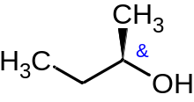 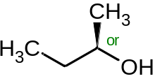
rac-(2R)-butan-2-ol rel-(2R)-butan-2-ol
Alternative: (2RS)-butan-2-ol (2R*)-butan-2-ol
For single center use of RS and R* looks more compact than prefixes rac/rel. Still, not so principal.
At the same time use of RS designation should be recommended for mixtures that have different amount of enantiomers.

- Substances with two and more stereocenters
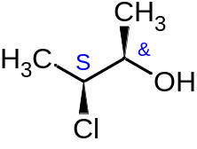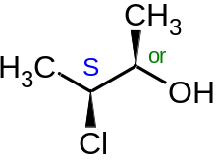
(2RS,3S)-3-chlorobutan-2-ol (2R*,3S)-3-chlorobutan-2-ol
No problem with names here – known center is defined with its descriptor and ‘racemic’ or ‘relative’ center is defined with RS and R*.

For two centers having alternative configurations we have two situations:
a. dependent centers
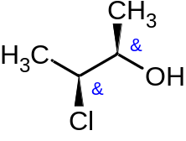 (two enantiomers are possible 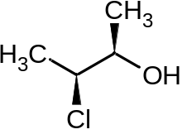and 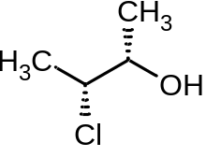)
PIN: rac-(2R,3S)-3-chlorobutan-2-ol (or alternative (2RS,3SR)-3-chlorobutan-2-ol
No problem with these names as they correctly define racemate.

a. independent centers
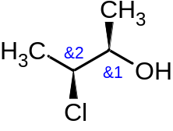 (four isomers 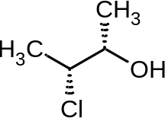 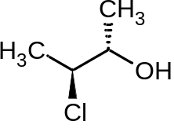 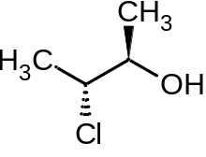)
Currently, there is no way to define two independent ‘and’ centers in chemical name.
Some use the following name (2RS,3RS;2RS,3SR)-3-chlorobutan-2-ol, but such name is rather long and there is no IUPAC recommendations concerning this way.

A possible solution can follow the logic of ESR and designating dependence or independence independence of stereogenic units. To distinguish dependent and independent centers we can use primes or superscript numbers.
For example, (2RS¹,3RS²) or (2RS,3RS’) will define independent centers. It seems that numbers are more recognizable.
As example we can check how four variants of cypermethrin names.

θ-Cypermethrin | Two stereoisomers:  R,1S,3R and S,1R,3S
No changes | (RS)-cyano(3-phenoxyphenyl)methyl (1SR,3RS)-3-(2,2-dichloroethen-1-yl)-2,2-dimethylcyclopropane-1-carboxylate (or variant with rac prefix?)
α-Cypermethrin | Two stereoisomers:  R,1S,3S and S,1R,3R
No changes | (RS)-cyano(3-phenoxyphenyl)methyl (1SR,3SR)-3-(2,2-dichloroethen-1-yl)-2,2-dimethylcyclopropane-1-carboxylate (or variant with rac prefix?)
ζ-Cypermethrin | Four stereoisomers:  S,1R,3S;  S,1R,3R;  S,1S,3R;  S,1S,3S
proposed | (S)-cyano(3-phenoxyphenyl)methyl (1RS¹,3RS²)-3-(2,2-dichloroethen-1-yl)-2,2-dimethylcyclopropane-1-carboxylate
Cypermethrin | A mixture of all possible  eight stereoisomers
proposed | (RS¹)-cyano(3-phenoxyphenyl)methyl (1RS²,3RS³)-3-(2,2-dichloroethen-1-yl)-2,2-dimethylcyclopropane-1-carboxylate

The same approach can be used for relative configurations.
For example, to define one of eight possible stereoisomers of cypermethrin:
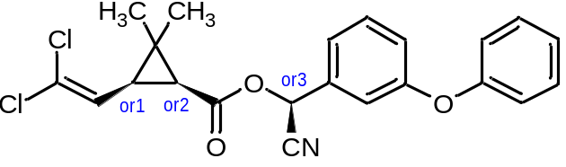
(R*¹)-cyano(3-phenoxyphenyl)methyl (1R*²,3R*³)-3-(2,2-dichloroethen-1-yl)-2,2-dimethylcyclopropane-1-carboxylate

- Use of rac and rel prefixes in names with spaces

It is stated that prefixes rac and rel are cited in front of the name, but it is not obvious how they should be cited in names with spaces.
Example 1:
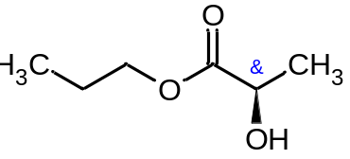 (racemate - R and S isomers)
hardly rac-propyl (2R)-2-hydroxypropanoate
should be ether propyl rac-(2R)-2-hydroxypropanoate or propyl (2RS)-2-hydroxypropanoate
What is the PIN?
Should we state that prefix rac is cited before the name of the fragment having stereo unit?

Example 2:
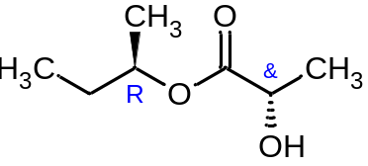(racemate R,R and R,S)
(2R)-butan-2-yl rac-(2R)-2-hydroxypropanoate or (2R)-butan-2-yl (2RS)-2-hydroxypropanoate
What is PIN?

Example 3:
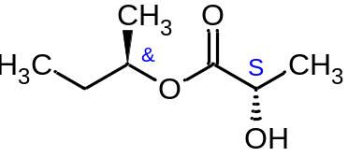
rac-(2R)-butan-2-yl (2S)-2-hydroxypropanoate looks ambiguous – not obvious a relation of rac to anion
(2RS)-butan-2-yl (2S)-2-hydroxypropanoate is unambiguous.
Should we state that rac (and rel) are not used if other parts of name also include stereodescriptors?
Example 4:
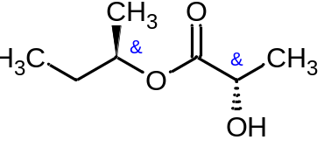(racemate R,S and S,R)
Obviously not rac-(2R)-butan-2-yl (2S)-2-hydroxypropanoate
rac-(2R)-butan-2-yl rac-(2S)-2-hydroxypropanoate or (2RS)-butan-2-yl (2SR)-2-hydroxypropanoate
The first name looks not so good, and it is not obvious whether the centers are dependent or not.
The second name looks better and can be treated as indication of dependent centers.

Example 5:
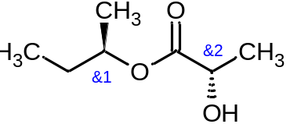(four isomers R,R; R,S; S,R; and S,S)
(2RS¹)-butan-2-yl (2SR²)-2-hydroxypropanoate
It seems we do not have other ways to indicate independence of the centers.
In the same way it is not so clear how to use rel prefix in close cases.
We do need a clarification of rac and rel use for the cases with several centers and name parts separated with space.

Conclusions
It is obvious the Enhanced Stereochemical Representation is a very convenient tool, especially considering its wide adoption for electronic representation of mixtures of stereoisomers. The corresponding extension of specification of such mixtures in chemical names is necessary for unambiguous description of the corresponding substances.
Division VIII can consider a short publication that will acknowledge ESR and provide recommendations for designation of stereoisomeric mixtures in chemical names.

